**PROGRAM 6: TOPOLOGICAL SORTING**

#include<stdio.h>

#include<time.h>

int a[50][50],n,indeg[50];

void indegree()

{

int j,i,sum;

for(j=0;j<n;j++)

{

sum=0;

for(i=0;i<n;i++)

sum+=a[i][j];

indeg[j]=sum;

}

}

void topology()

{

int i,u,v,t[50],s[50],tos=-1,k=0;

indegree();

for(i=0;i<n;i++)

{

if(indeg[i]==0)

s[++tos]=i;

}

while(tos!=-1)

{

u=s[tos--];

t[k++]=u;

for(v=0;v<n;v++)

{

if(a[u][v]==1)

{

indeg[v]--;

if(indeg[v]==0)

s[++tos]=v;

}

}

}

printf("The Topological Sequence is:\n");

for(i=0;i<n;i++)

printf("%d ",(t[i]+1));

}

int main()

{

clock_t start,end;

double time;

int i,j;

printf("Enter number of nodes:\n");

scanf("%d",&n);

printf("\nEnter the adjacency matrix:\n");

for(i=0;i<n;i++)

{

for(j=0;j<n;j++)

scanf("%d",&a[i][j]);

}

start = clock();

topology();

end = clock();

time = ((double)(end - start))/CLOCKS_PER_SEC;

printf("\nTime taken : %lf\n",time);

}

OUTPUT:

Graph 1:

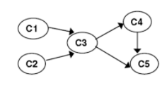

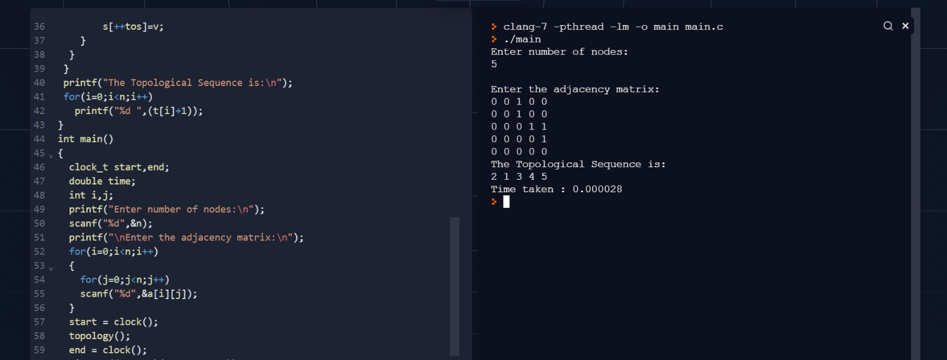

Graph 2:

